Build a Biome Task
Year 3 Content Descriptors-
Locate and collect information and data from different sources, including observations
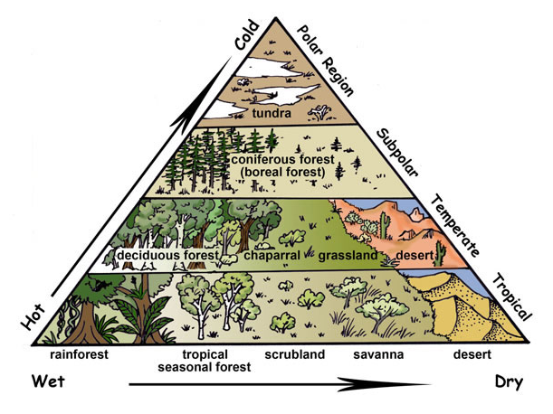
Understand the main climate types of the world and the similarities and differences between the climates of different places
Year 4 Content Descriptors-
Locate and collect information and data from different sources, including observations
Understand the importance of environments, including natural vegetation, to animals and people

TASK: Your task is to create your own biome. Your biome can be constructed in a box of your choice as a diorama. Use whatever other materials you need and be as creative and detailed as you can!
You need to include your research with your biome. How you choose to present this is up to you e.g. you can stick the information on to your diorama in parts or you can have a separate piece of paper etc. Make sure you follow the student rubric to ensure you meet all the criteria.
Student Rubric- Marking Criteria
 | 1 mark  (minimal) | 2 marks (satisfactory) | 3 marks  (high)
Name and location of your biome + brief description
Average annual rainfall and temperature range
At least 5 animals in biome- drawn, labelled and described
Plants in your biome- drawn, labelled and described
Why is your biome important/an important place in the world?
Resources- at least two sources used were recorded e.g book, website URL
Neatness and creativity- effort displayed
 |  | Total | /21
Comment:

